Alexandria First Presbyterian Church

141 Little York-Mount Pleasant Road
Milford, New Jersey

Founded 1797

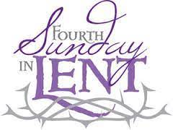

Gathered in God’s grace and led by the Holy Spirit,
Alexandria First Presbyterian Church joyfully worships, prayerfully seeks,
and gratefully shares as a loving family growing in Jesus Christ.

Fourth Sunday in Lent
March 19, 2023
10:00 a.m.

Usher: Charlie Tiedeman Worship Assistant: LuAnn Keefe
Director of Music Ministry: Stefanie Watson Minister: The Rev. Nicholas Hatch

ORDER OF WORSHIP
March 19, 2023 - Fourth Sunday in Lent

THE CHURCH GATHERS . . .

PRELUDE The Fair Hills of Eire. O Amy Beach

WORDS OF WELCOME

MINUTE FOR MISSION Per Capita Lainey Johns

INTROIT Lay Me Low Trad. Shaker, Daniel Schwandt Lay me low
where the Lord can find me.
Lay me low
where the Lord can hold me.
Lay me low
where the Lord can bless me.
Lay me low
Lord, lay me low.

*CALL TO WORSHIP
Leader: Lord Christ, open our eyes
All: to see clearly the light of the world.
Leader: Holy Spirit, illumine our minds,
All: to percieve God’s glory shining among us.
Leader: Almighty God, prepare our hearts
All: to see, to trust, to worship the Messiah

. . . TO PRAISE AND CONFESS

*HYMN OF PRAISE 85 What Wondrous Love Is This

*LENTEN PRAYER
Lord God, Great I am, you are living water. As we worship you this day show us who we are: channels of your love and vessels of your grace; through Jesus Christ our Lord. Amen

*RESPONSE OF PRAISE (please sing)

What wondrous love is this that caused the Lord of bliss
to bear the heavy cross for my soul, for my soul,

to bear the heavy cross for my soul!

PRAYER OF CONFESSION
God of compassion and mercy, we sometimes fail to see what you are doing in the world. We want you to act in ways we predict, but we forget: you do what is good, not what is expected. Forgive us when we do not recognize your miracles. Forgive us when we doubt the wisdom of your actions. Most of all, forgive us when we do not respond to your call, ignoring what we need to do to show the world your love and grace.

SILENT REFLECTION AND CONFESSION OF SIN
Leader: Lord, in your mercy,
All: hear our prayers.

KYRIE 574 Lord, Have Mercy upon Us
Lord, have mercy upon us. Christ, have mercy upon us. Lord, have mercy upon us.

ASSURANCE OF PARDON
One: . . . friends, hear and believe the good news of the gospel.
In Jesus Christ we are forgiven.
All: Thanks be to God! Amen.

HYMN 355 Hear the Good News of Salvation
Hear the good news of salvation: Jesus died to show God’s love.
Such great kindness! Such great mercy! Come to us from heaven above.
Jesus Christ, how much I love you! Jesus Christ, you save from sin!
How I love you! Look upon me. Love me still and cleanse within.

THE PEACE
Leader: Since God has forgiven us in Christ, let us forgive one another.
The peace of our Lord Jesus Christ be with you all.
All: And also, with you.
Leader: Staying in our seats, I invite you to turn to your neighbor and greet each other with the Peace of Christ.

. . . TO EXPERIENCE GOD’S WORD

ANTHEM Be Thou My Vision Chancel Choir
arr. Hal Hopson
CHILDREN’S SERMON
Children and youth are excused for Sunday school.

HYMN 322, blue hymnal, remain seated Spirit of the Living God

PRAYER FOR ILLUMINATION

OLD TESTAMENT LESSON 1 Samuel 16:1-13

NEW TESTAMENT LESSON John 9:1-41
Leader: The word of the Lord.

All: Thanks be to God.

SERMON Opening Our Eyes The Rev. Nicholas Hatch

. . . TO RESPOND IN FAITH

*HYMN OF AFFIRMATION 280 Amazing Grace

SILENT PRAYER

HYMN, sing twice Hear Our Prayer, O Lord
Hear our prayer, O Lord, hear our prayer, O Lord.
Incline thine ear to us, and grant us thy peace.

PRAYERS OF THE PEOPLE (SHARING JOYS AND SORROWS)
Leader: Lord, in your mercy,
All: hear our prayers.

THE LORD’S PRAYER
Our Father, who art in heaven, hallowed be thy name. Thy kingdom come, thy will be done, on earth as it is in heaven. Give us this day our daily bread; and forgive us our debts, as we forgive our debtors; and lead us not into temptation, but deliver us from evil. For thine is the kingdom and the power and the glory, forever. Amen.

PRESENTATION OF TITHES AND OFFERINGS
Offertory Billie’s Song Valerie Capers
*Doxology 592
Praise God from whom all blessings flow; praise Him, all creatures here below:
praise Him above, ye heavenly host: praise Father, Son, and Holy Ghost. Amen.
*Prayer of Thanksgiving
. . . TO GO OUT TO SERVE

*CLOSING HYMN 324 Open my Eyes, That I May See

*CHARGE AND BENEDICTION

*CONGREGATIONAL RESPONSE, insert Bless the Lord
POSTLUDE Troubled Water Margaret Bonds

*Please Stand If You Are Able

Sanctuary flowers this week given by the Keefe’s in memory of Phylis Kinney.

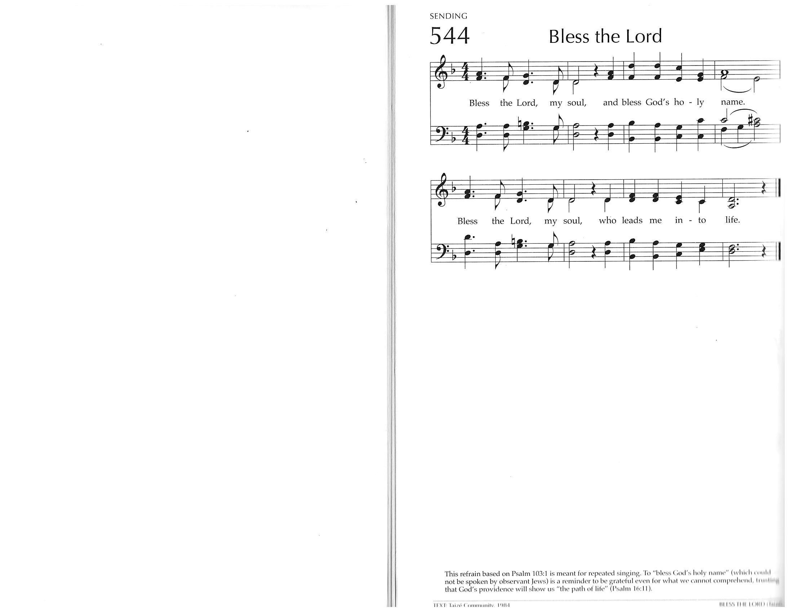

Announcements
GAME DAY
March 16th after worship families are invited to join the Youth Group and Membership Teams for a fun game day. Bring your favorite board game! Pizza and beverages provided; $5.00 donation appreciated.

Per Capita Month: For the month of March we are highlighting per capita and encouraging each member to consider contributing. Per capita is $42.50 for each member of AFPC. You may send in your per capita check to the church office or simply put it in the offering plate (with “per capita” in the memo line). Thank you for your continued support and commitment to our church and denomination.

CHRISTIAN RESPONSE to Racism Classes
March 26th Join us after worship in the conference room.

CARE TO SHARE
Care-to-Share is our huge Lenten service project. Join us as we prepare 200 lunch bags for Milford, Frenchtown and Flemington Food Pantries. It is amazing to watch God’s people come together for such a great cause. Food tags are in the Narthex starting today!

LUNCH BUNCH
March 28th at Noon
Bring your sandwich, chips and drinks will be provided. Bring a friend!

